**Design of an Optimal Network for the University of Lahore Campus**



**Semester Project Proposal**

**Subject Name: Computer Communication and Networks**

**Submitted by**

**Ahamed Najah 70141084**

**N Mohamed Nuzky 70141107**

**K F M Fazeen Shahfan 70141328**

**Supervised by**

**Engr. Abeera**

**Department of Computer Engineering**

**The University of Lahore**

**Table of Contents**

1. Introduction 3

2. Problem Statement 3

3. Aims and Objectives 3

4. Literature Review 3

5. Utilization of Results 4

6. Estimated Budget 4

7. Methodology and Block Diagram 4

Methodology 4

8.References 5

# **1. Introduction**

The University of Lahore, with its four teaching engineering departments, Library, Admin block, and other offices, requires a reliable and efficient wired network infrastructure to meet the increasing connectivity demands of students, faculty, and staff. This project aims to design and implement a scalable network that ensures optimal connectivity for all users while leveraging the available 50 Mbps fiber optic connection. By incorporating automated IP configuration through DHCP and employing a well-structured topology, the network will provide fair bandwidth distribution and seamless connectivity. This initiative is essential for enhancing productivity, ensuring data integrity, and fostering a collaborative environment within the campus.

# **2. Problem Statement**

The University of Lahore faces several challenges in providing a robust network infrastructure for its campus. The existing setup lacks efficient wired connectivity across the teaching engineering departments, Library, Admin block, and other offices. Additionally, the absence of proper bandwidth management strategies leads to unfair resource allocation, impacting productivity. There is also no automated system in place for IP configuration, resulting in inefficiencies and potential errors. This project aims to address these challenges by designing a scalable and efficient network solution tailored to the specific needs of the campus.

# **3. Aims and Objectives**

List the primary goals of your project:

1. To design a robust network topology that ensures optimal wired connectivity.
2. To implement automated IP configuration using DHCP for all users.
3. To manage bandwidth efficiently and ensure fair usage across all systems.
4. To assess the societal and environmental impact of the proposed solution.

# **4. Literature Review**

The design and implementation of an optimal network infrastructure have been extensively discussed in academic and industry literature. Studies emphasize the importance of scalable and efficient networks in academic institutions to support teaching, learning, and administrative tasks. [1] Cisco Networking Academy resources, (2011) provide practical insights into configuring switches, routers, and bandwidth management strategies for large-scale networks. [2] Research by Kumar et al. (2019) on "Efficient Network Design for Educational Institutions" underscores the need for bandwidth optimization and automated IP configuration to enhance user experience. [3] Gupta, R., & Sharma, P. (2021). "Advanced Networking Solutions for Universities" discuss the role of DHCP in automating IP assignment and ensuring consistent connectivity. [4] Ahmed, Z., & Khan, H. (2020). "Environmental Impacts of Network Implementations" provide insights into minimizing the carbon footprint of large-scale networks. [5] The work of Chen, L., & Zhang, Y. (2020), "IoT Integration in Educational Networks," explores the integration of IoT devices in modern campus networks, providing strategies for ensuring compatibility and data security. This literature forms the foundation for the proposed project, ensuring that the design leverages best practices and proven methodologies to address the specific needs of the University of Lahore.

# **5. Utilization of Results**

The results of this project will provide significant benefits to the University of Lahore:

1. Improved Connectivity: All students, faculty, and staff will have reliable wired connectivity, enabling seamless access to resources and communication tools.
2. Efficient Bandwidth Management: The implementation of bandwidth allocation strategies will ensure fair and optimal usage of the available 50 Mbps connection, improving productivity and user experience.
3. Automated IP Configuration: With DHCP-enabled IP configuration, network management will become more efficient, reducing errors and administrative overhead.
4. Scalability and Future Expansion: The designed network will be scalable to accommodate future growth, ensuring long-term sustainability.
5. Environmental Considerations: The efficient design will minimize energy consumption, aligning with sustainable practices.

These results will collectively enhance the university's digital infrastructure, fostering a more productive and connected academic environment.

# **6. Estimated Budget**

estimated cost of the project is around 2000$.

# **7. Methodology and Block Diagram**

## **Methodology**

1. Phase 1: Network Requirements Analysis and Design:
   1. Conduct a detailed analysis of the campus network requirements, including the number of users, expected traffic, and hardware requirements.
   2. Define components such as switches, routers, access points, and cabling. Develop a comprehensive topology diagram considering scalability and efficiency.
2. Phase 2: Core Network Setup and Configuration:
   1. Implement the core network design by setting up switches, routers, and access points.
   2. Configure IP addressing and subnets, utilizing DHCP for automated IP assignment.
   3. Test individual components for proper functionality.
3. Phase 3: Final Integration, Testing, and Impact Assessment:
   1. Integrate all components into a cohesive network.
   2. Conduct comprehensive testing to ensure fair and optimal bandwidth usage.
   3. Assess societal and environmental impacts of the network design.

**Block Diagram**

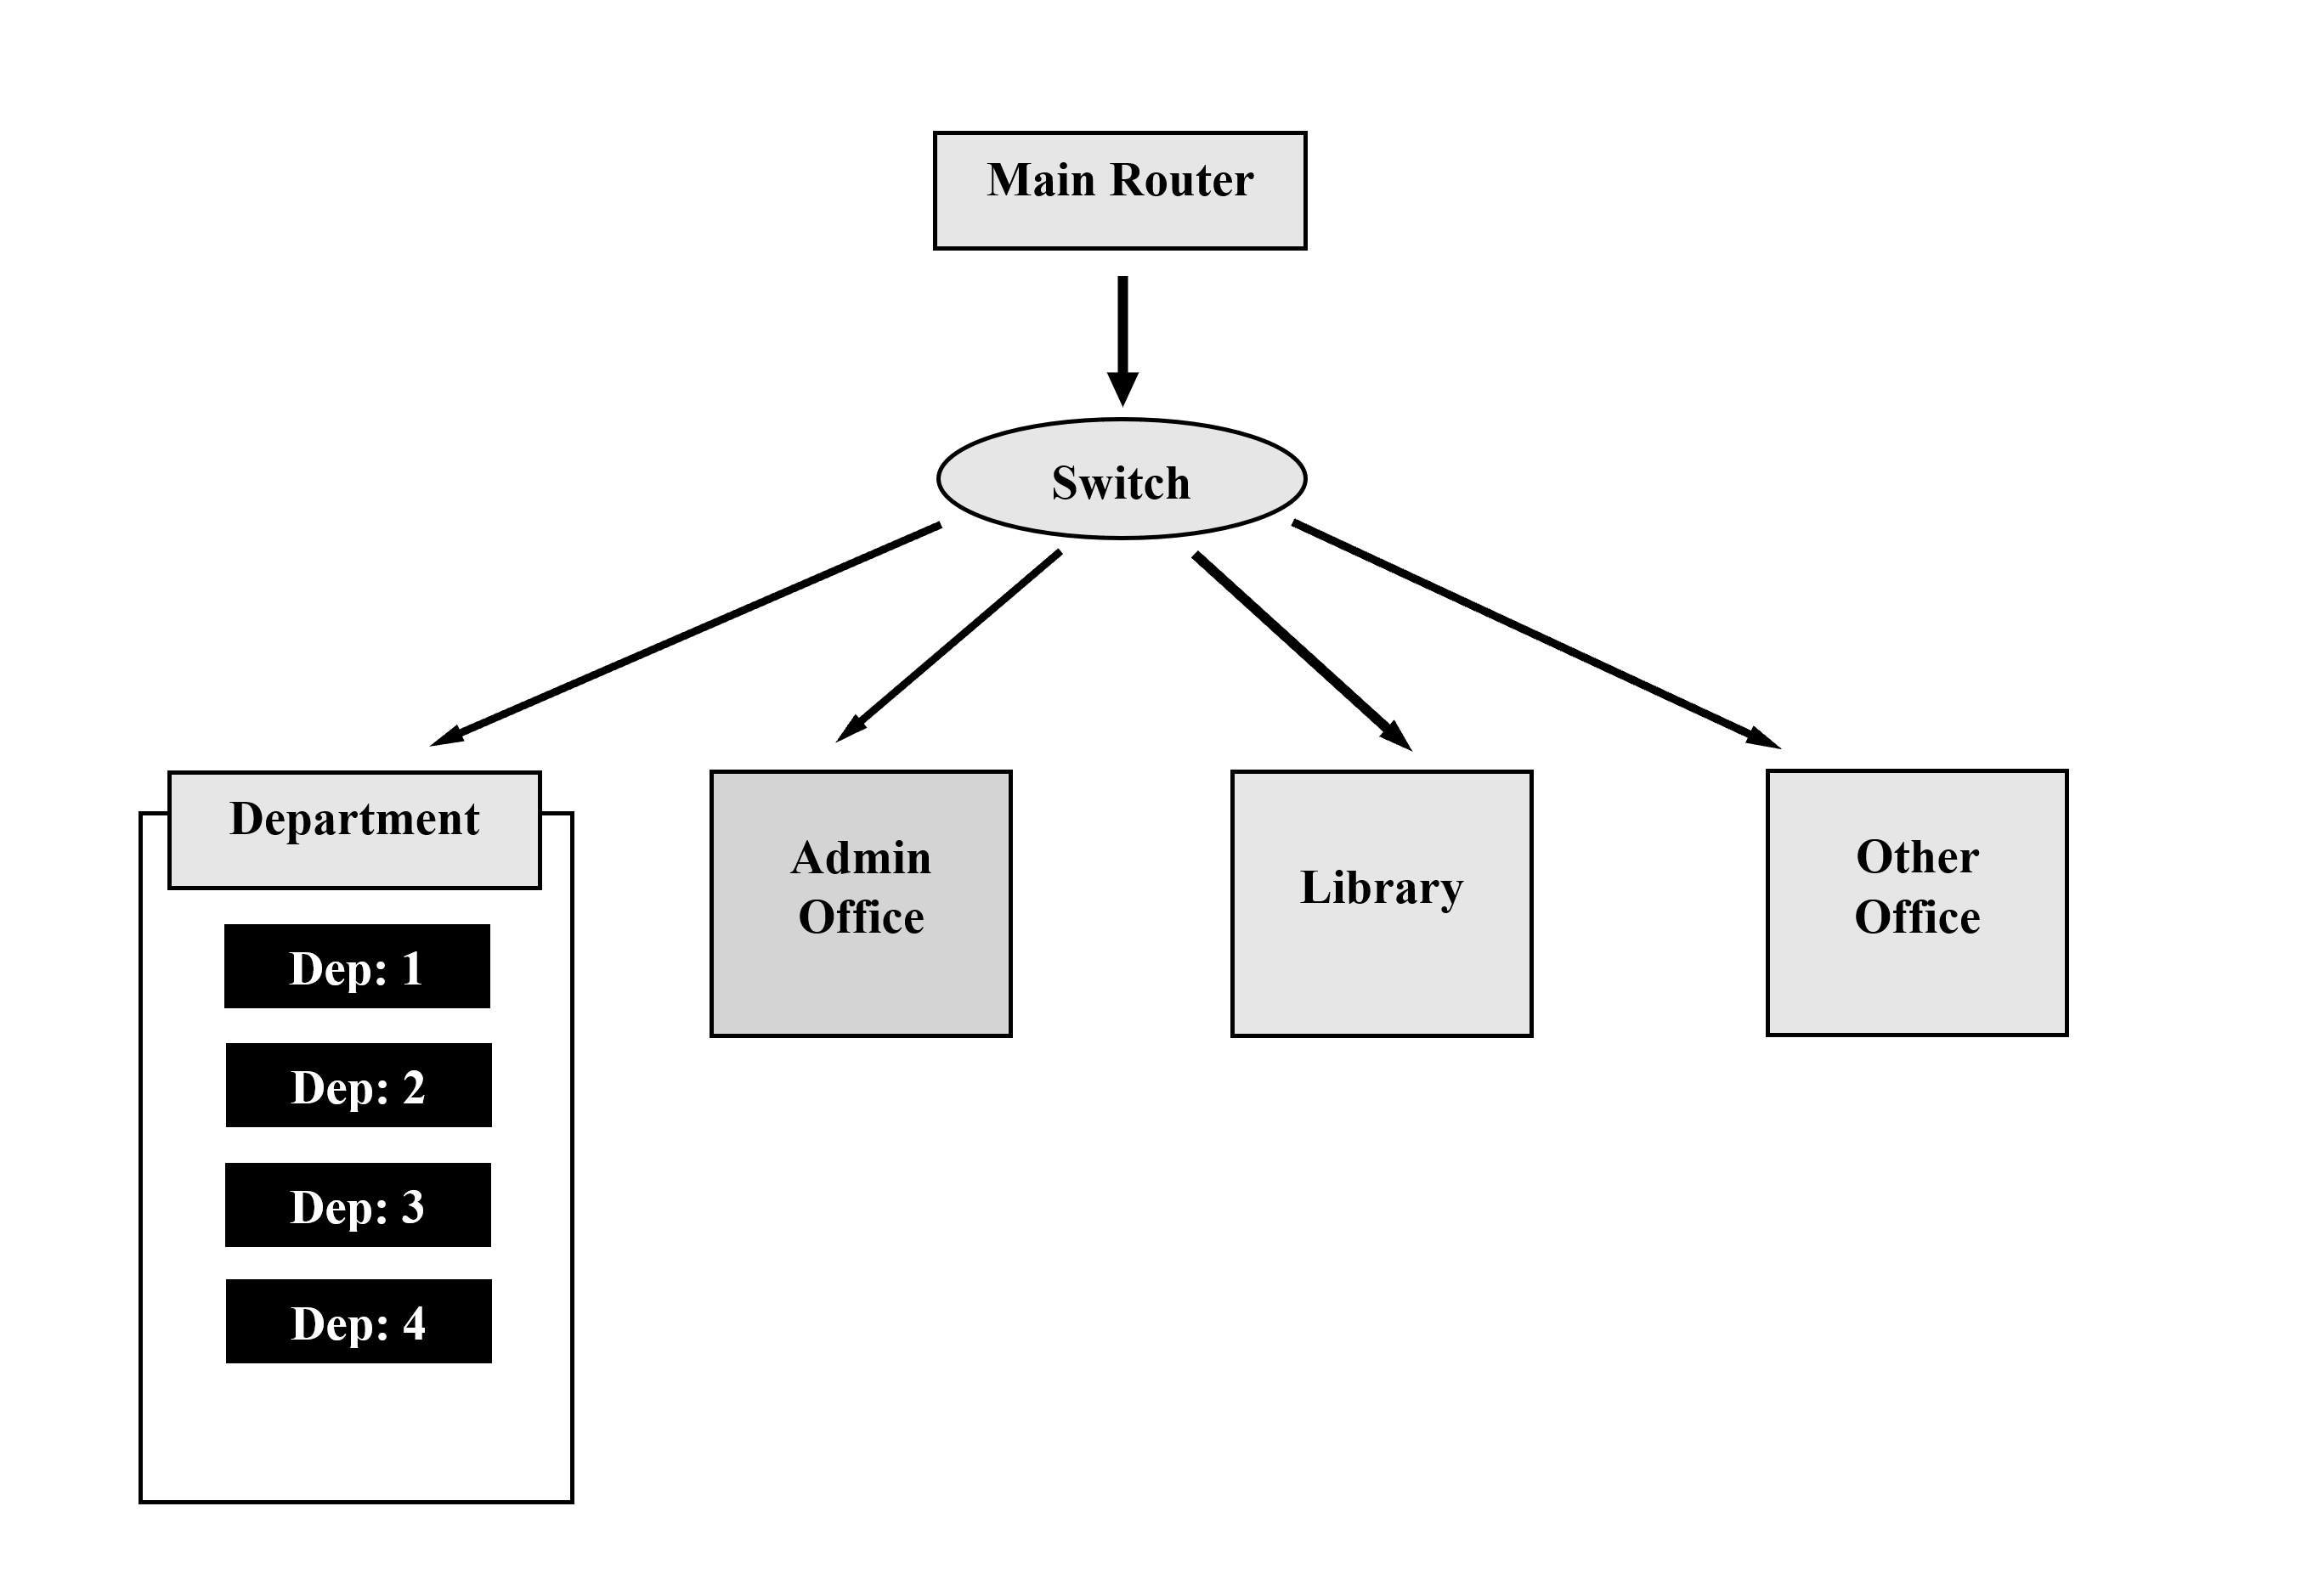

# **8.References**

|  |  |
| --- | --- |
| [1] | A. S. &. W. D. J. Tanenbaum, "Computer Networks," 2011. |
| [2] | Kumar, "bandwidth optimizations & automated IP configuration," 2019. |
| [3] | G. R. &. S. P, "Advance networking Solutions for the university," 2021. |
| [4] | Z. A. &. H. khan, "Environmental impects of network implementations," 2020. |
| [5] | Y. Z. &. L. Chen, IOT Itegration in Educatioanal Network, 2020. |